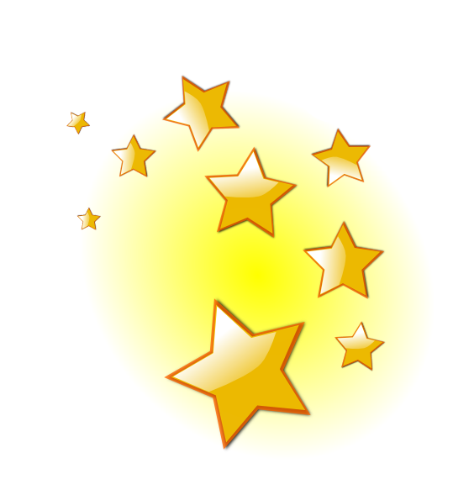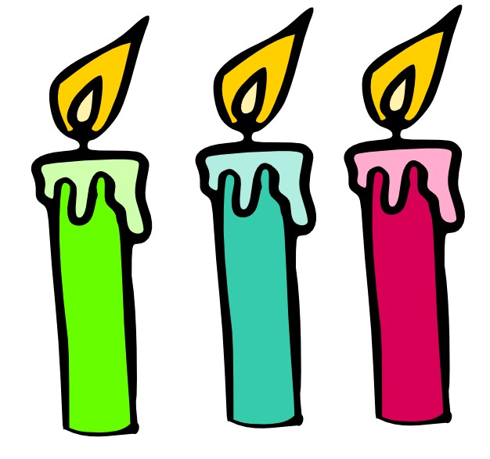

**Light**

examples:

examples:

Lamp, bulb and candle

Sun, firefly and star+s

Artificial light

Natural light

can be:

A kind of energy

September 16th / 2019

is:

Articificial light

Natural light